Introducing Constructivist Media Decoding
15 minute PD Presentation for K-12 all Subjects
We intend these slide decks and presenter guides to enable you (even without training from Project Look Sharp) to be able to introduce the Constructivist Media Decoding approach and resources to other educators. Please modify the slides and use your own words to address the needs of your audience. The presenter guides include links to resources for specific audiences such as early elementary and 2ndary subject areas.

Time | Slide | NOTES to presenter | Your Notes
start | 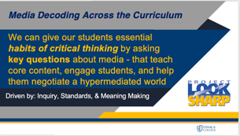  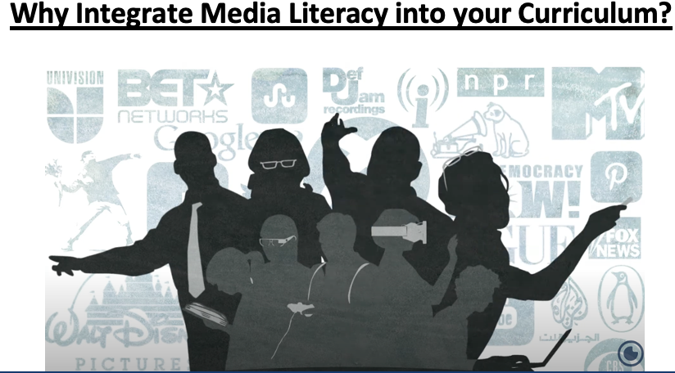 | Explain the focus of the PD. Depending on your audience emphasize that this approach will help you to: 1) teach your core curriculum and critical thinking, 2) engage ALL students, 3) address challenging topics, 4) incorporate SEL, PBL, DEI, etc. Feel free to add your own framing about the importance of integrating media literacy.
 | 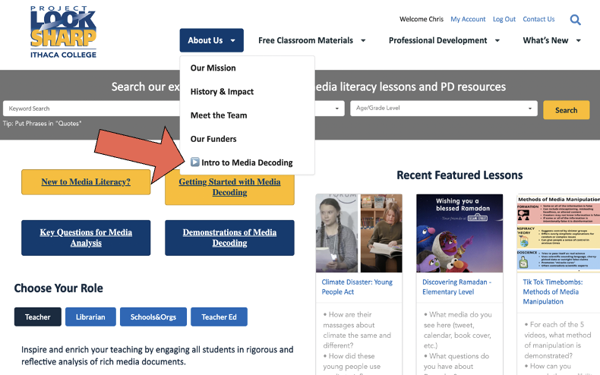 | By diversifying the texts in our classrooms and by teaching our students to continually question the constructed nature of knowledge and their own interpretations, we give them the power to read their worlds.
 |  | But how to we do this given the overwhelming demands on our time and curriculum? Constructivist Media Decoding enables all educators to teach these habits AND our core subject area content and skills to all students.
1 min | VIDEO | 5.5 minutes: This short video will give an overview of the methodology and free resources for this work.  https://www.youtube.com/watch?v=aVCwRELkXmo
7  min | HANDOUT  Categories and Questions for Decoding  OR for  Early Childhood | Handout Categories & Questions for Media Decoding  This methodology of Constructivist Media Decoding is based on the use of key decoding questions and categories that can be applied to the analysis of all media documents in the classroom, including our textbooks, video clips, charts and graphs, posters, etc. If educators at all levels and in all subjects asked just one of these questions every day, we would have a more robust democracy.
 | Quiet Reading  and  Pair Share | Take a minute to look over these questions. Pick one category or question that you think is most essential to ask your students. In a minute I will ask you to share that with a partner.  When most people seem ready, have them talk with a partner.

11 min | 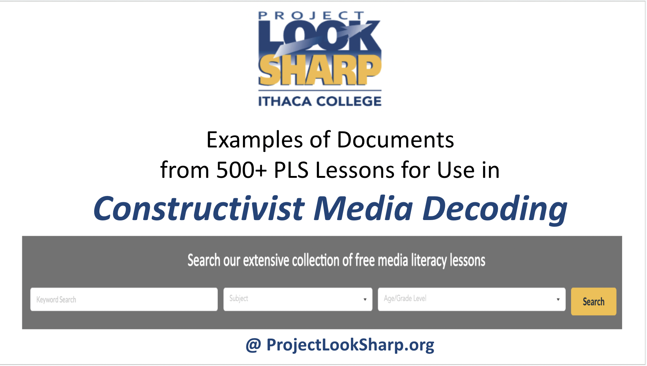 | For over 25 years Project Look Sharp, with funding from foundations, school districts, and universities, has been publishing media decoding lessons for integrating student centered, inquiry-based media decoding into the core curriculum. Here are just a few examples of some of the documents in the 500+ lessons on the website.
 | Slide Array of Lessons | Choose the slides that fit your audience from the Slide Array of Lessons on the pull down option: Slide Sets for Delivering PD that is on our page: Resources for Delivering PD on CMD.
14 min | 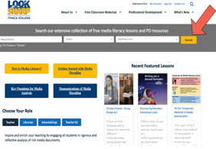  If extra time have them search for lessons | To find lessons for a particular topic like disinformation, or Africa, or nutrition, or physics - use the keyword search on the left together with the grade level and subject. You can further filter your search by many criteria including learning standards, by length of the activity, or by media type such as social media, web videos, charts and graphs, etc., Then scan the titles for lessons of interest. All materials are completely free, but you will need to sign up for a free account.
15 min | Survey | We will end with a survey to assess how I can best support you in the integration of constructivist media decoding into your classrooms and curriculum. Please fill out this survey.  Hand out hard copy or make a digital survey. Here is a model.

